AF_Reunion Dinner_Review_V2

傳理學院今年踏入50周年，電影學院率先於1月23日晚舉行師生歡聚晚宴，為學院未來一年連串院慶活動揭開序幕。
As HKBU entered into its 50th anniversary, the Academy of Film held its reunion dinner at Cordis Hotel, Mongkok on 23rd January (Tuesday), to kick off for the series of celebratory events throughout the year. The officiating guests of the Academy of Film 50th anniversary reunion dinner included Honourable Ma Fung-kwok, S.B.S., J.P., Chairman of the HKBU Council and the Court Mr Cheng Yan-kee, President Professor Roland Chin, Dean of the School of Communication Professor Huang Yu, and Director and Chair Professor of the Academy of Film Eva Man.
晚宴由香港電影發展局主席馬逢國(中)、浸會大學校董會暨諮議會主席鄭恩基(左二)、浸大校長錢大康教授(右二)、傳理學院院長黃煜教授(左)及電影學院總監文潔華講座教授(右)主禮。 | 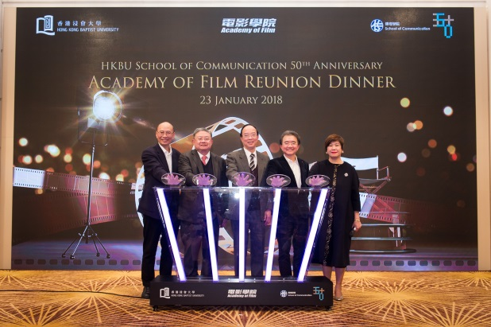
超過250位電影學院的師生、校友及業界友好參加晚宴，氣氛熱鬧。The reunion dinner gathered around 250 faculty, students, alumni, staff and friends from the film industry. A number of faculty and students showcased their skills and talents in a variety of performances, creating a lively and entertaining evening for all. | 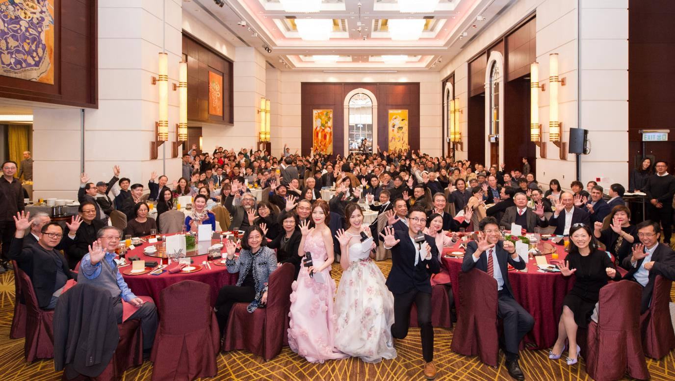
何煒麟校友的魔術，獲得現場熱烈掌聲。  Keanu Ho | 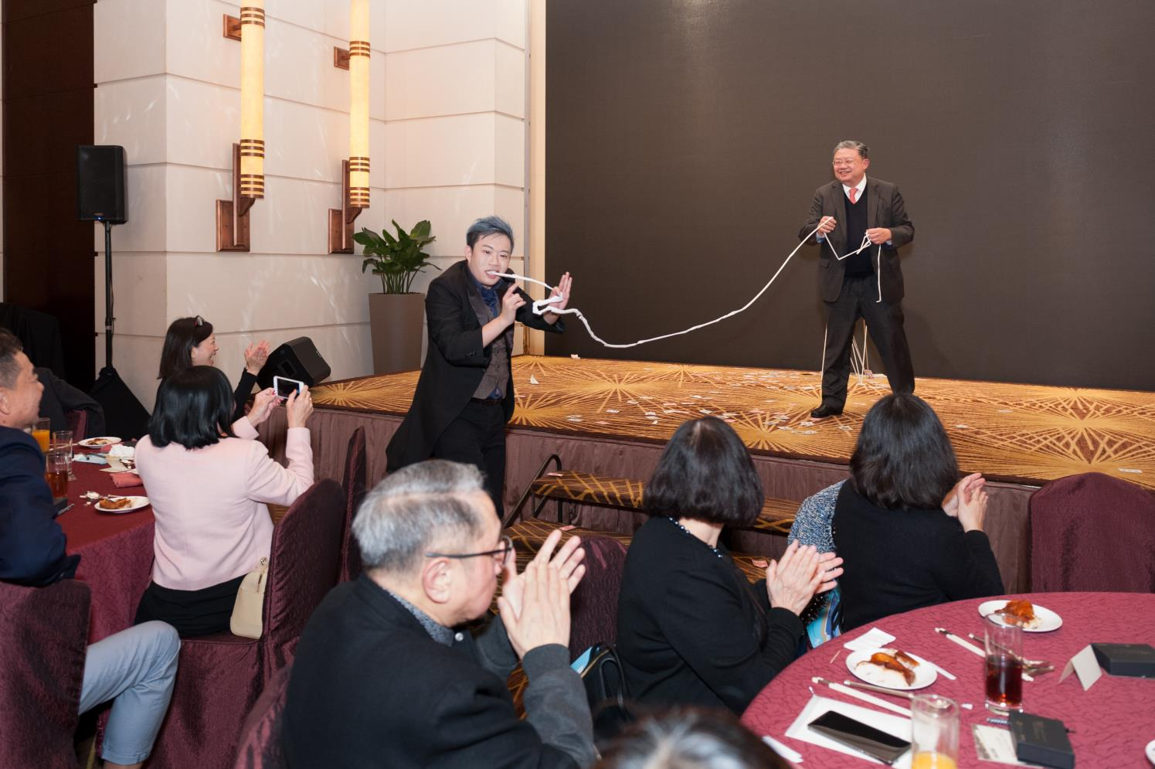
學生和校友施展渾身解數表演。 | 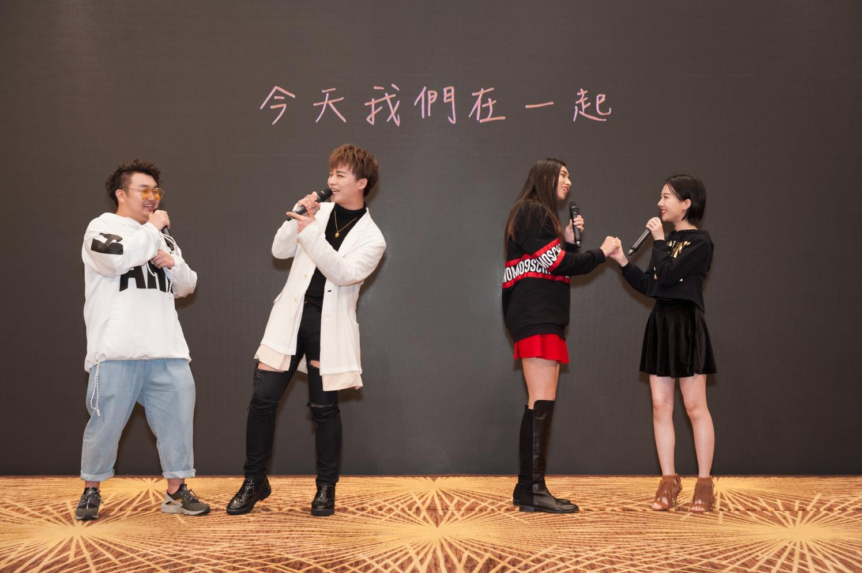  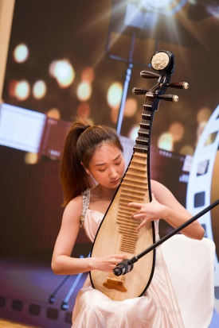
程仁富校友演出搞笑話劇，電影《點五步》導演陳志發校友  及著名演員兼電影學院講師廖啟智客串演出。(4) Weeds on Fire, a film directed by alumnus Steve Chan and written by alumnus Yellow Wong is performed on stage. The photo shows one of the highlights of the guest performer who plays Steve Chan and the renowned actor and Academy of Film lecturer Liu Kai Chi. | 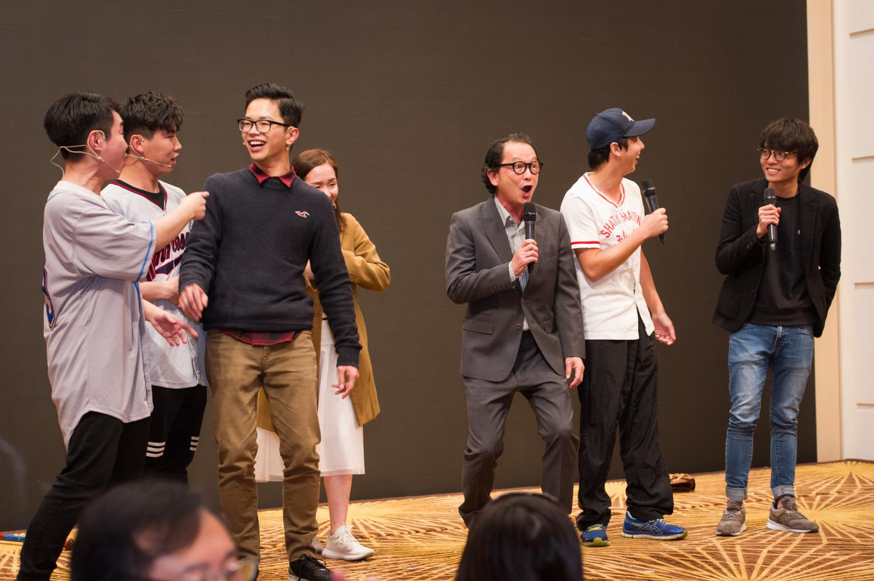
教授電影配樂的高級講師Robert J. Ellis-Geiger博士，即興彈奏及演唱英語經典流行曲。 | 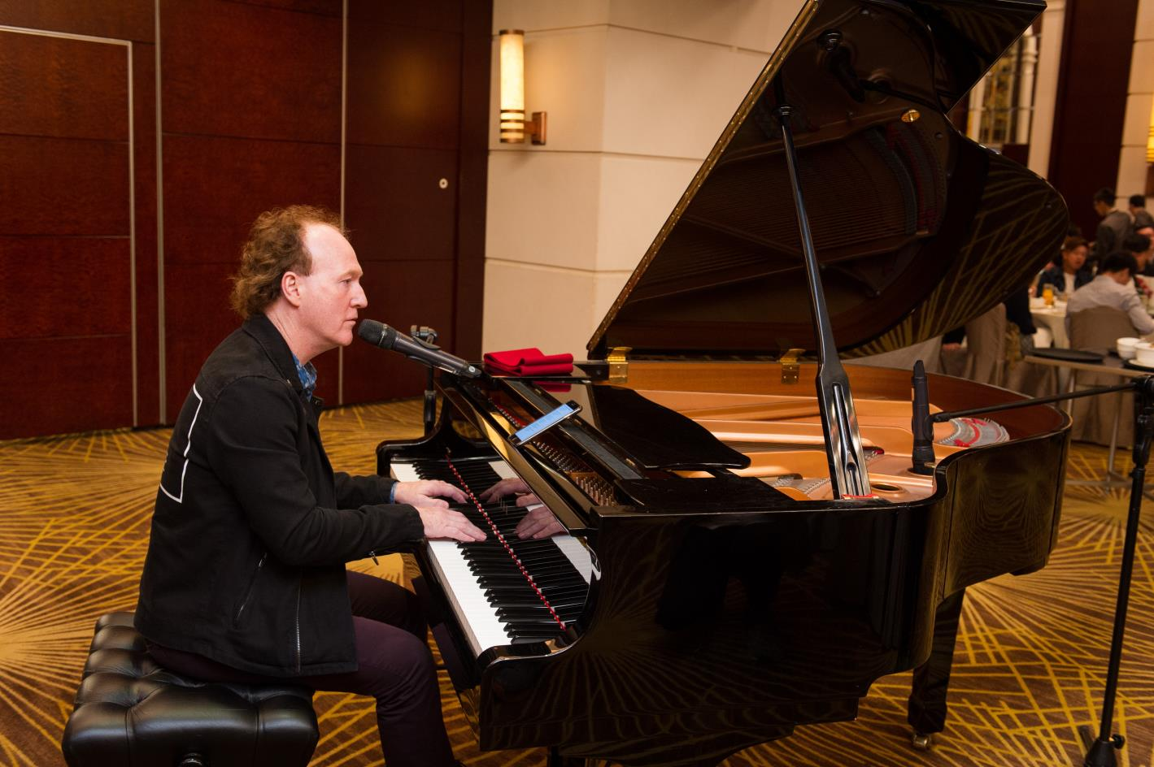
不同年代的校友與老師聚首一堂，把握合照機會。 | 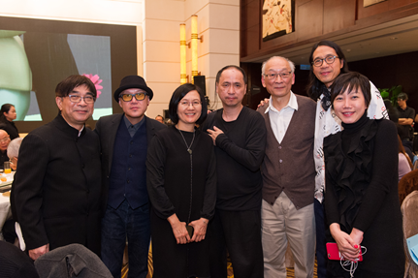  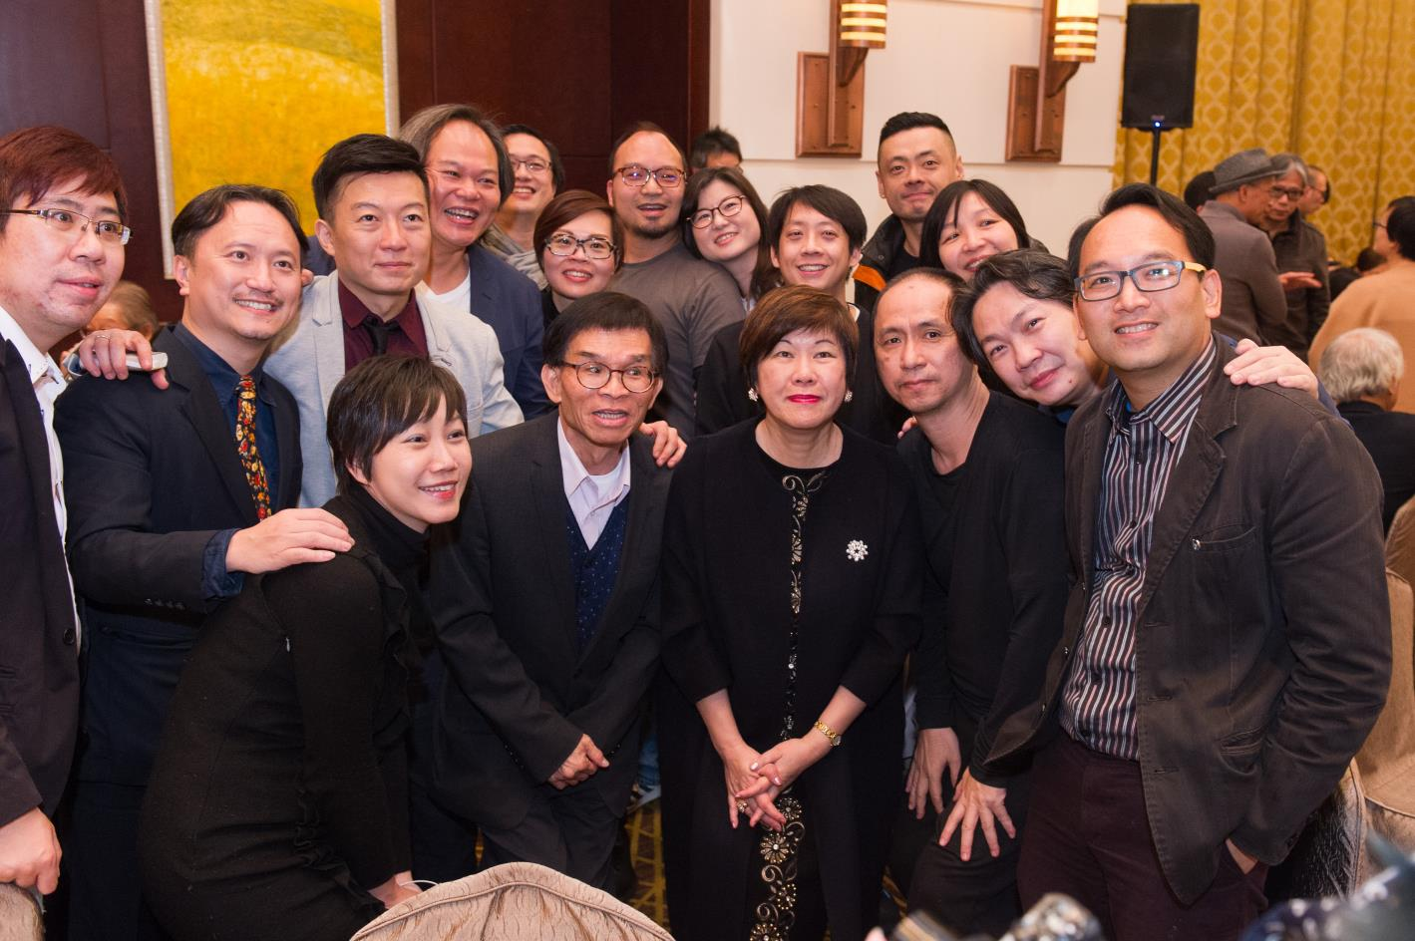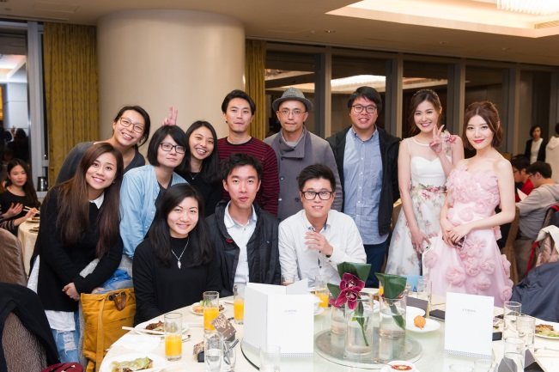
2018年慶祝活動預告  - 逢周三舉辦「放大電影」經典電影放映會  - 3月主題電影放映會 - Film Tells: Hong Kong  - 6月紀錄片國際學術會議 – International Conference: Documentary Film, Regional, Theoretical and Political Parameters  - 11月全球大學生影視獎 | 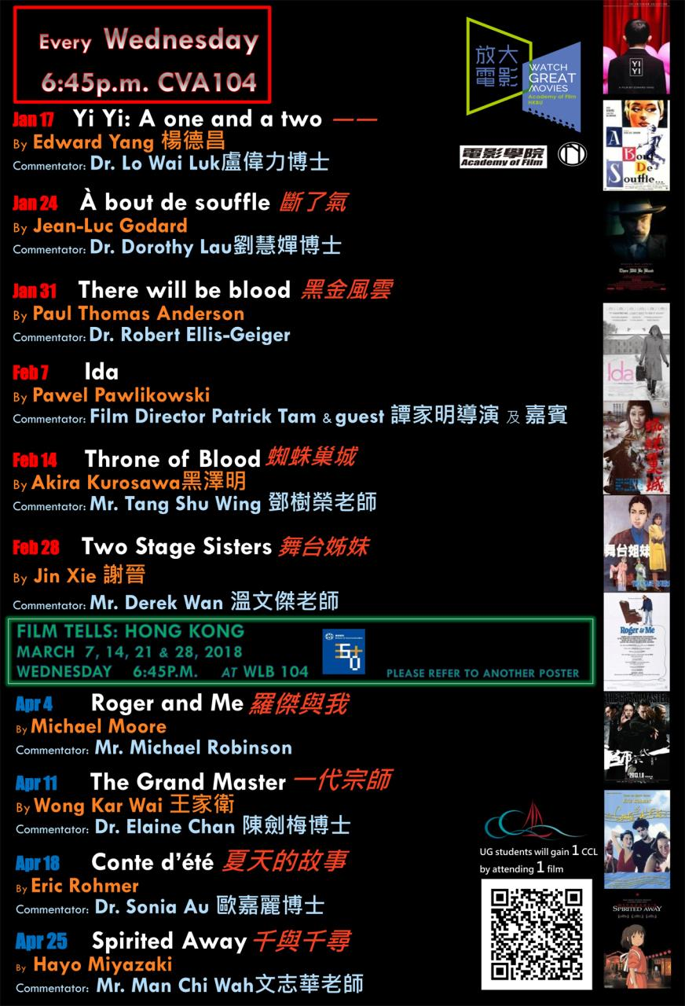  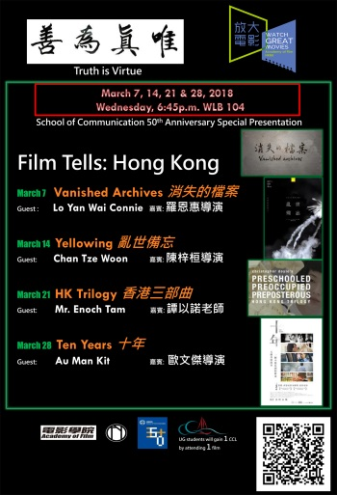  
傳理學院50周年院慶特別項目
- 「傑出傳理人」獎現正接受提名，獎項將於11月30日院慶晚宴上頒發。
- 傳理視藝大樓天台將改建成為天台花園，成為戶外課室。
- 傳理學院正在籌建人工智慧媒體創新實驗室與虛擬實境及擴張實境工作室，預計於2018-2019學年投入運作。
此為模擬圖，僅供參考。

